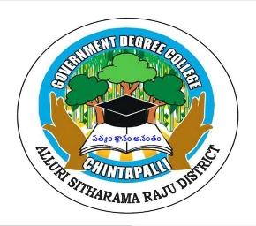
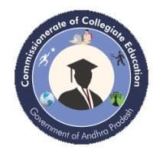
Government Degree College, Chintapalli Affiliated to Andhra University
Chintapalli, Alluri Sitharama Raju -District, AP.
Phone no: 9666739207. Email.lD: qdcchintapalli@qmail.com
STUDENT QUIZ

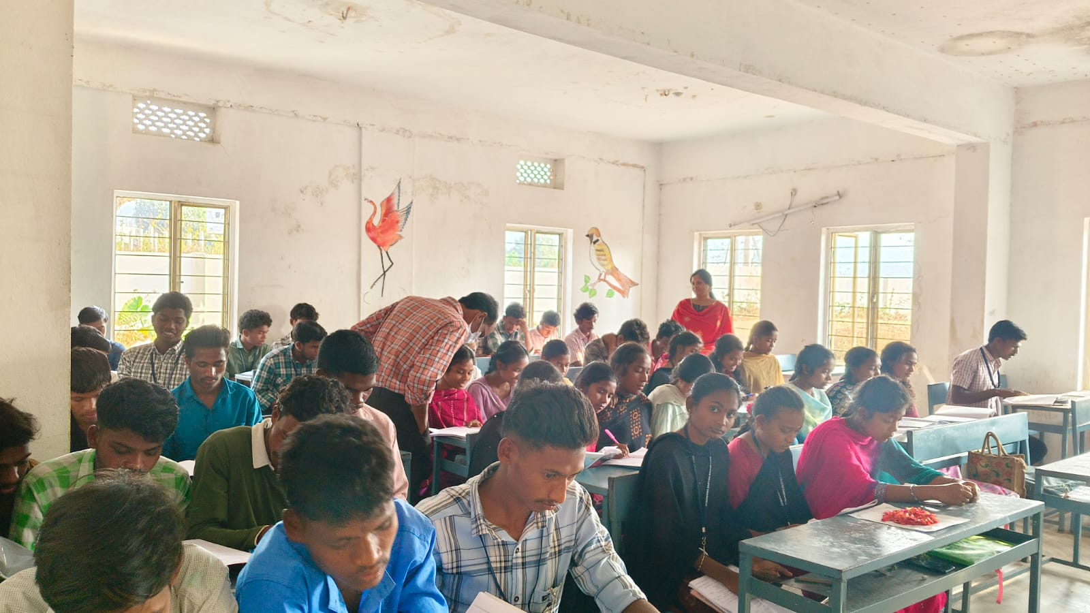
The Department of Commerce at Government Degree College (GDC), Chintapalli conducted a Quiz and Essay Writing Competition on GST 2.0 on 10/06/2025 to enhance students’ knowledge about the Goods and Services Tax reforms in India. The program aimed to encourage students to understand the importance of GST and its role in the country’s economic development.
Many students from the Commerce Department actively participated in the competitions. The quiz competition included questions related to GST concepts, tax structure, input tax credit, and the reforms introduced in GST 2.0. The essay writing competition provided an opportunity for students to express their ideas and understanding about GST, its benefits, and its impact on businesses and the economy. Faculty members of the Commerce Department organized and supervised the competitions.
Overall, the quiz and essay writing competitions on GST 2.0 were informative and successful. Such academic activities help students gain better understanding of taxation and encourage them to stay updated with current economic reforms in India.
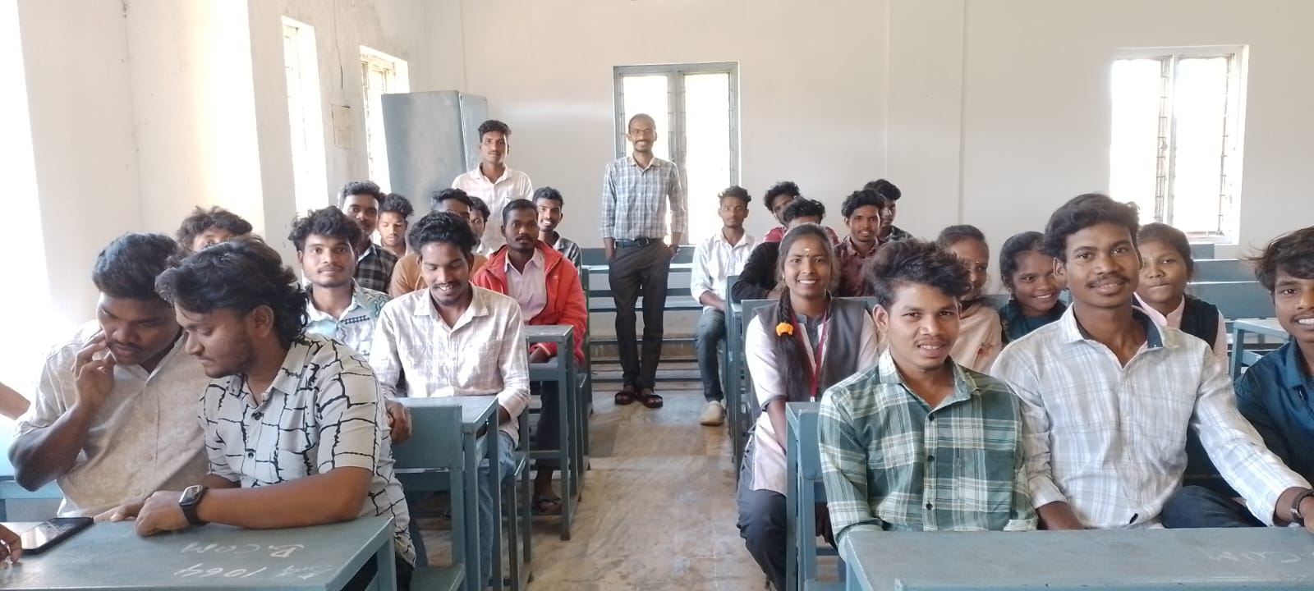
STUDENT GROUP DISCUSSION

Group discussions are an integral part of the teaching–learning process at Government Degree College, Chintapalli. As a modern pedagogical practice, group discussions are regularly conducted across various departments to enhance students’ communication skills, critical thinking, and subject knowledge. Faculty members actively organize these sessions as part of continuous internal evaluation and academic enrichment activities.
During these sessions, students are divided into small groups and assigned relevant topics related to their syllabus, current affairs, or social issues. They are encouraged to express their opinions, exchange ideas, and engage in meaningful dialogue. This interactive method helps students develop confidence, clarity of thought, and the ability to articulate their viewpoints effectively. It also fosters teamwork and leadership qualities among participants.
The college adopts group discussions as one of its key modern teaching methods, alongside seminars, quizzes, and study projects. These activities ensure active student participation and make learning more dynamic and engaging. Departments such as English and Social Sciences frequently conduct discussions on language skills, literature, and contemporary issues to broaden students’ perspectives.
Furthermore, group discussions serve as a platform for students to improve their analytical abilities and prepare for competitive examinations and job interviews. By participating regularly, students gain exposure to diverse viewpoints, which enhances their decision-making and problem-solving skills.

