Government Degree College, Chintapalli
Alluri Sitha Rama Raju District- 531111

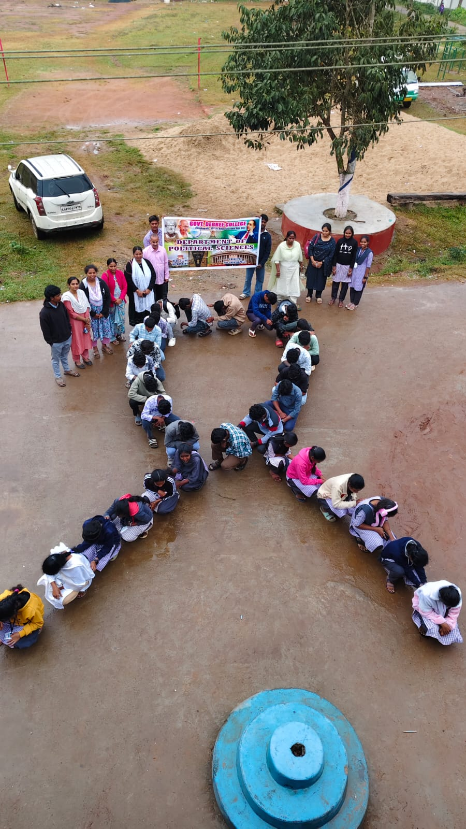
Red Ribbon Club

The Red Ribbon Club (RRC) at Government Degree College Chintapalli is a student-based health awareness club commonly found in Indian colleges. Even if specific published details of your college unit are limited online, its structure and activities follow the national model established by the Government of India.
The Red Ribbon Club (RRC) at Government Degree College (GDC), Chintapalli, is an important student-led initiative aimed at promoting awareness about HIV/AIDS, health, hygiene, and social responsibility among youth. The club functions under the guidance of the National AIDS Control Programme (NACP) and plays a significant role in educating students, especially in rural and tribal areas, about crucial health issues and preventive measures.
The primary objective of the Red Ribbon Club is to create awareness about HIV/AIDS, sexually transmitted diseases (STDs), and the importance of leading a healthy lifestyle. The club also works to eliminate stigma and discrimination against people living with HIV/AIDS. By empowering students with accurate knowledge and encouraging open discussions, the club helps in building a supportive and informed community within the college campus.
At GDC Chintapalli, the Red Ribbon Club actively organizes various awareness programs and outreach activities throughout the academic year. One of the major events conducted is the observance of World AIDS Day on December 1st. On this occasion, students participate in rallies, poster presentations, slogan writing competitions, and awareness campaigns to spread knowledge about HIV prevention and care. These activities not only enhance student participation but also extend awareness to the local community.
The club also conducts health and hygiene awareness programs, focusing on personal cleanliness, nutrition, and disease prevention. Special sessions are arranged to educate students about the dangers of drug abuse, alcohol consumption, and unsafe practices. Guest lectures by healthcare professionals and counselors are frequently organized to provide expert guidance and address student queries.
Another significant activity of the Red Ribbon Club is promoting voluntary blood donation. The club motivates students to participate in blood donation camps and educates them about the importance of donating blood to save lives. These initiatives instill a sense of social responsibility and compassion among students.

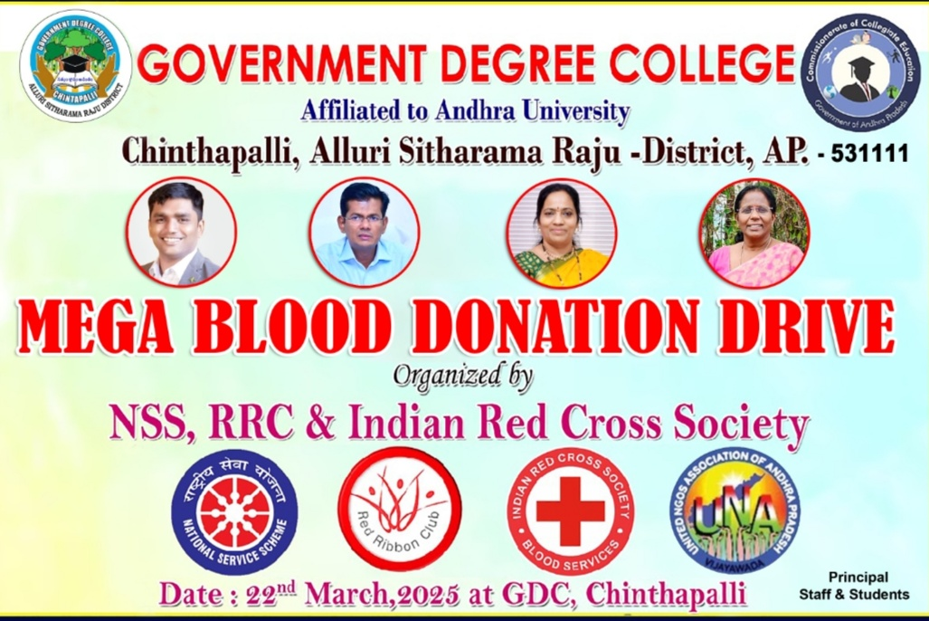
Peer education is a key component of the Red Ribbon Club at GDC Chintapalli. Selected student volunteers are trained to act as peer educators, who then share knowledge and awareness messages with their fellow students. This approach ensures better communication, as students feel more comfortable discussing sensitive topics with their peers.
The Red Ribbon Club also emphasizes the development of leadership and communication skills among students. By actively participating in organizing events and awareness programs, students gain confidence, teamwork abilities, and a sense of responsibility toward society.
In conclusion, the Red Ribbon Club at Government Degree College, Chintapalli, serves as a vital platform for promoting health awareness and social consciousness among students. Through its various activities and initiatives, the club contributes significantly to building a healthier and more informed youth community. It not only educates students about HIV/AIDS and related issues but also encourages them to become responsible citizens who can positively influence society.

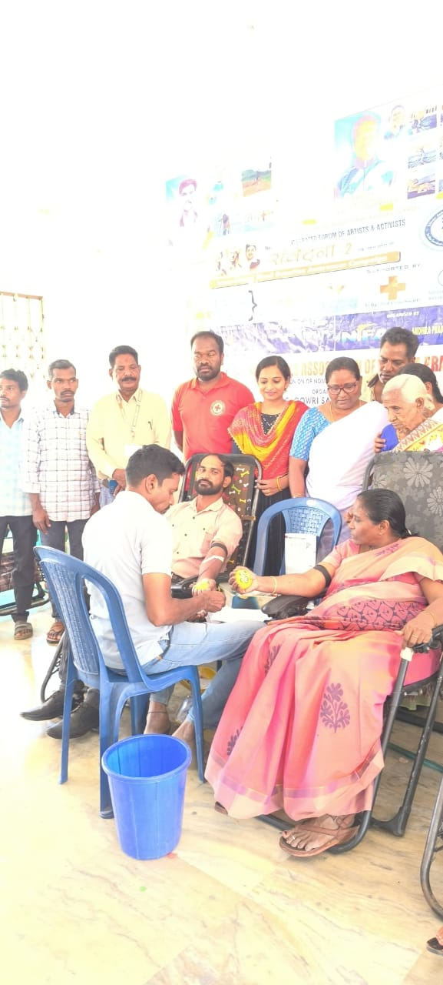

🎯 Objectives of RRC at GDC Chintapalli
- To educate students about HIV/AIDS, STDs, and reproductive health
- To reduce stigma and discrimination toward affected people
- To develop students as peer educators and social change agents
- To promote voluntary blood donation
- To encourage healthy and safe lifestyles among youth

🏫 Activities Conducted
Typical activities that are (or can be) conducted at GDC Chintapalli include:
- World AIDS Day (December 1) programs
- Awareness rallies and campaigns
- Poster making & slogan competitions
- Health and hygiene awareness sessions
- Blood donation camps
- Drug abuse awareness programs
- Guest lectures by medical experts
- Peer education programs
Many colleges conduct activities like poster campaigns, rallies, and health awareness drives to spread awareness among students and the community.

👩‍🎓 Importance for Students
- Builds leadership and communication skills
- Encourages social service and community engagement
- Improves health awareness and responsible behavior
- Provides opportunities for participation in outreach programs

📌 Role in GDC Chintapalli
At GDC Chintapalli, the Red Ribbon Club plays an important role in:
- Promoting health awareness among tribal and rural students
- Supporting government health initiatives
- Creating a responsible and informed student community

